DATA ANALYTICS POWERED BY TABLEAU

PROJECT TITLE

**VOYAGE VISTA: ILLUMINATING INSIGHTS FROM UBER EXPEDITIONARY ANALYSIS**

**TEAM ID:NM2023TMID07783**

**TEAM LEADER: J.S.JENIFA**

**TEAM MEMBERS: D.J.DERISHA**

**G.S. KAVYA**

**A.B.SIVAPRIYA**

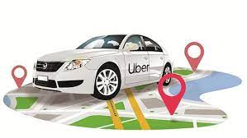

**PROJECT REPORT**

1. INTRODUCTION
   1. OVERVIEW
   2. PURPOSE
2. PROBLEM & DESIGN THINKING
   1. EMPATHY MAP
   2. IDEATION & BRAINSTORMING
3. RESULT
4. ADVANTAGES AND DISADVANTAGES
5. APPLICATIONS
6. CONCLUSION
7. FUTURE SCOPE
8. PERFORMANCE TESTING

VOYAGE VISTA: ILLUMINATING INSIGTHS FROM UBER EXPEDITIONARY ANALYSIS

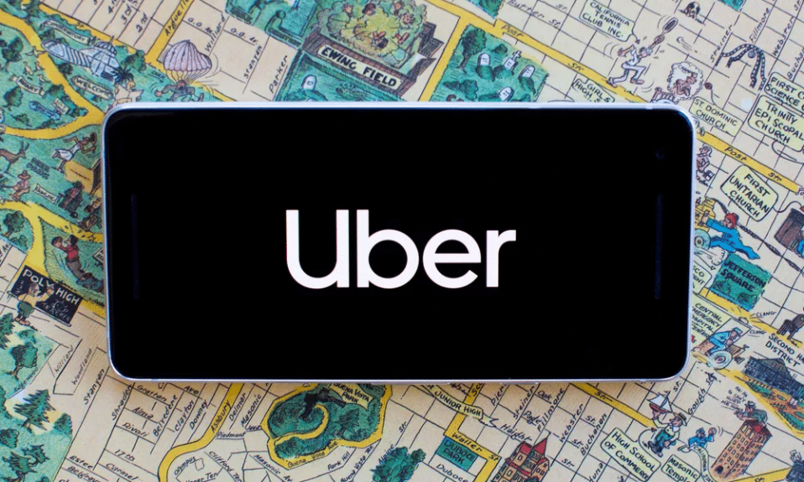

1.INTRODUCTION

* 1. PROJECT DESCRIPTION

**Uber Driver Analysis refers to the analyzing the number of trips taken by uber drivers can provide insights in to their overall activity and the demand for rides in specific areas. Daily, Weekly or Monthly analysis**: **Uber’s Data can be analyzed on a Daily, help Weekly, Monthly basis to understand the trends and patterns of trip volumes. This analysis can help to identify peak hours or days of high demands and optimize driver availability during those times. Trips can be analyzed based on geographic regions or specific cities to identify areas with higher demand. This analysis can be help uber drivers decide where to focus their diving efforts for maximum efficiency and profitability.**

**1.2 PURPOSE**

**Uber is a transportation company with an app that allows passengers to hail a ride and drivers to charge fares and get paid. More specifically, Uber is a ridesharing company that hires independent contractors as drivers. It's one of many services today that contribute to the sharing economy, supplying a means of connecting existing resources instead of providing the physical resources themselves.**

**The company was founded by Travis Kalanick and Garrett Camp in 2009, and is headquartered in San Francisco. The company has an estimated 110 million users worldwide.**

**How does it work?**

**Uber links passengers with drivers using the Uber app. Generally, the drivers own their own car. The company does also offer rental or lease on cars through third party partners like Hertz, Get Around and Fair. Uber fleet is an app for those managing squads of drivers.**

**Uber offers rides under a dynamic pricing model for both drivers and passengers.**

**2. PROBLEM DEFINITION & DESIGN THINKING**

**Uber is struggling with subsidies, competition, and complaints, resulting in layoffs, cost reductions, higher prices, longer wait times, and dissatisfaction among drivers and customers due to low fares and high fuel prices, leading to financial losses and many drivers quitting**.

**2.1 EMPATHY MAP**

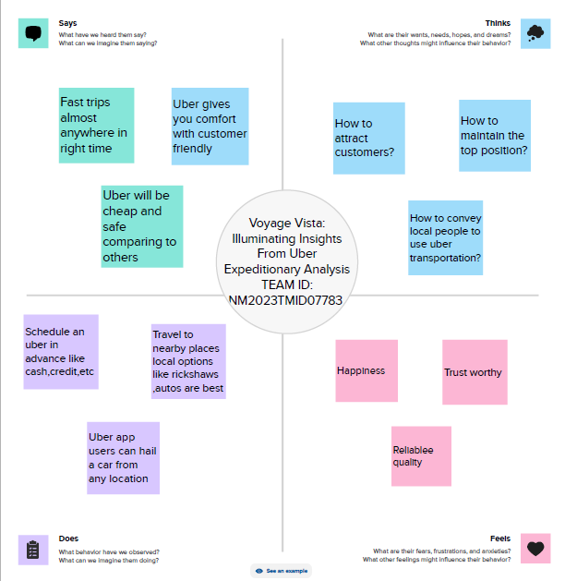

**2.2 IDEATION AND BRAINSTORMING MAP**

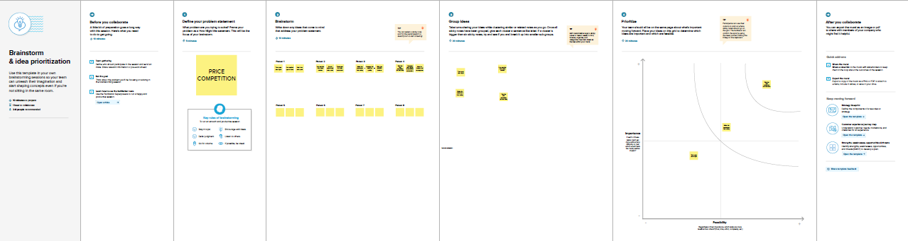

**3. RESULT**

**DASHBOARD**

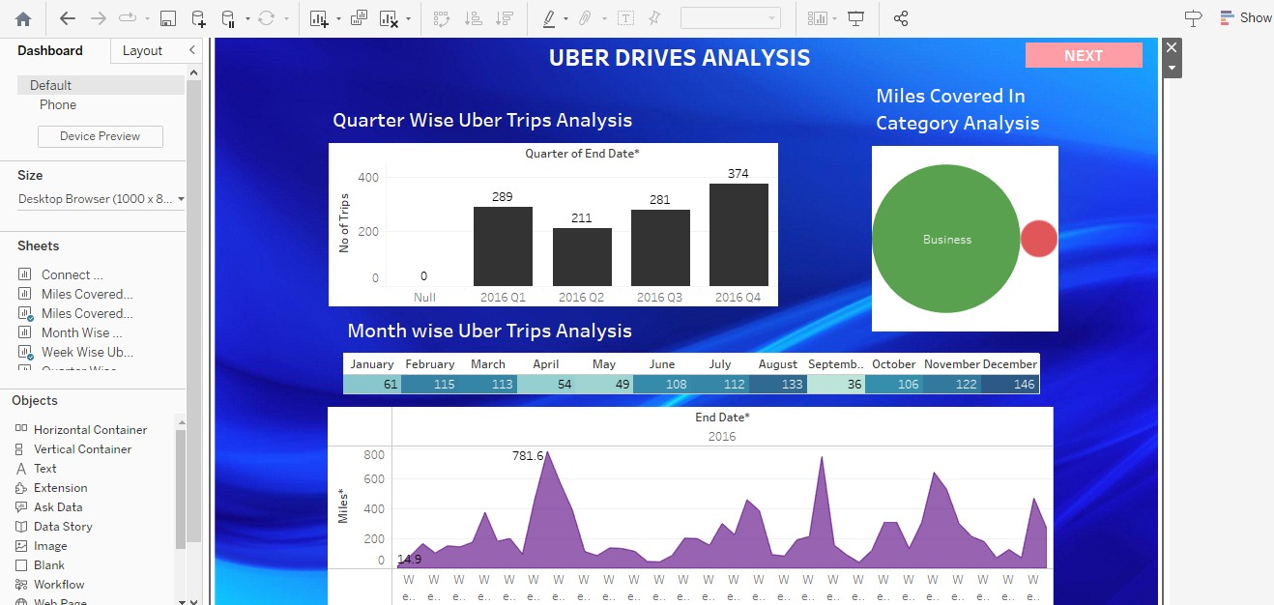

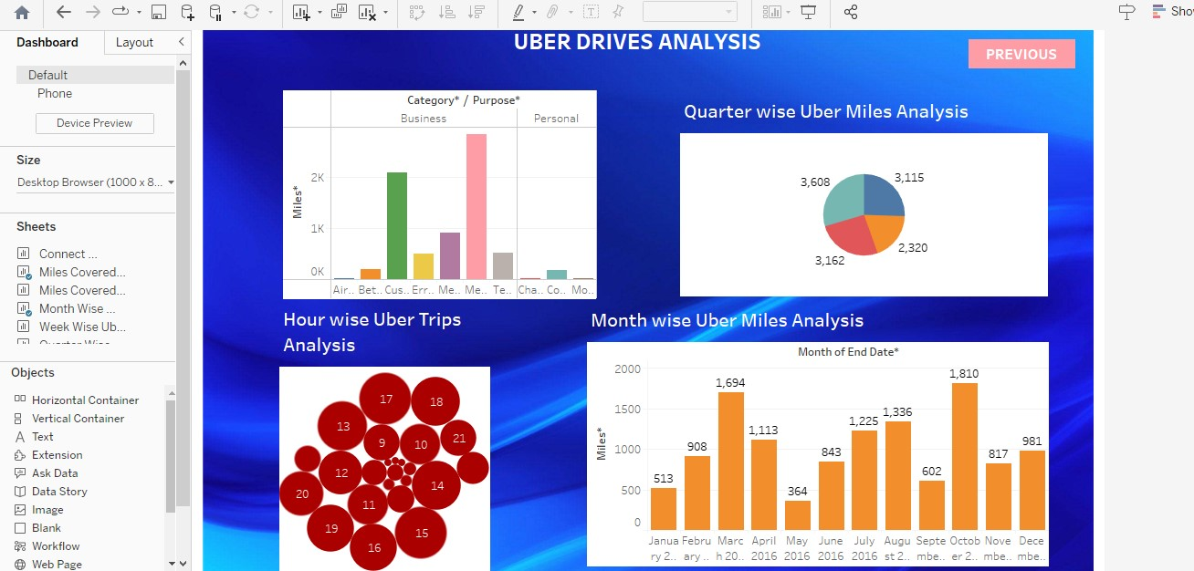

**STORY**

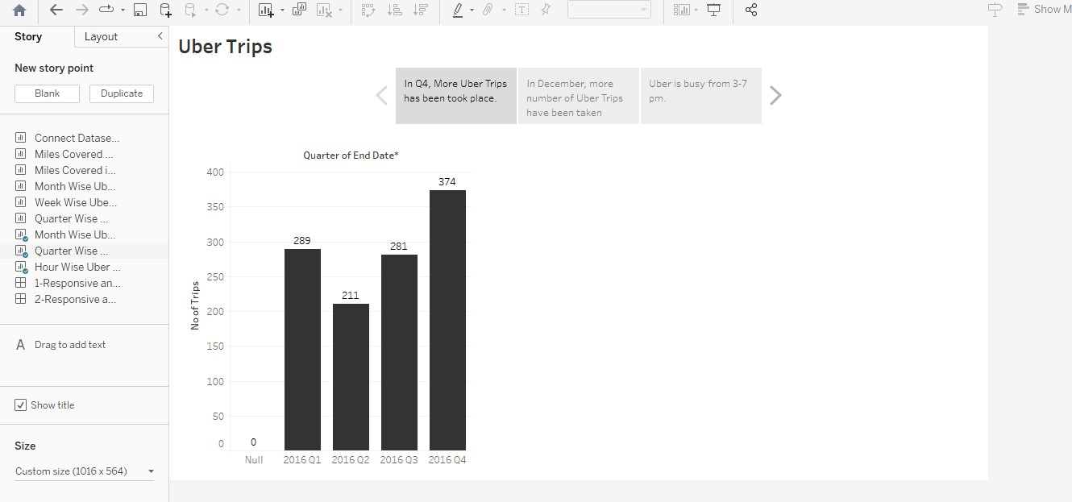

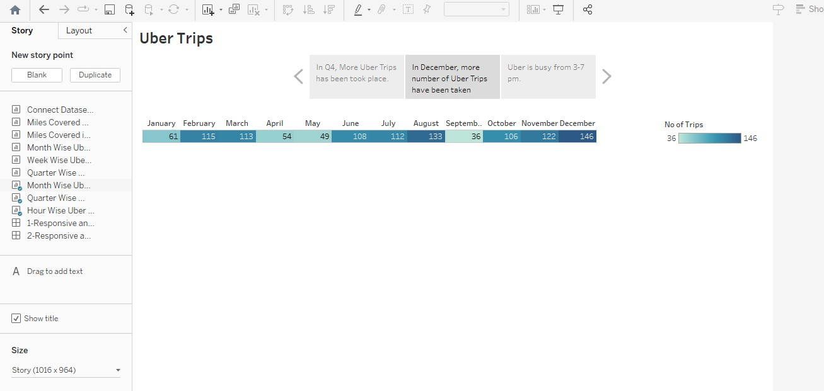

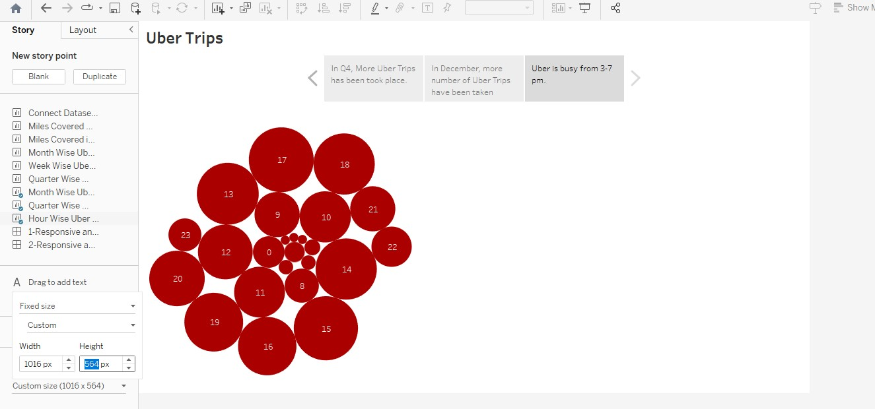

**4. ADVANTAGES & DISADVANTAGES**

**ADVANTAGES**

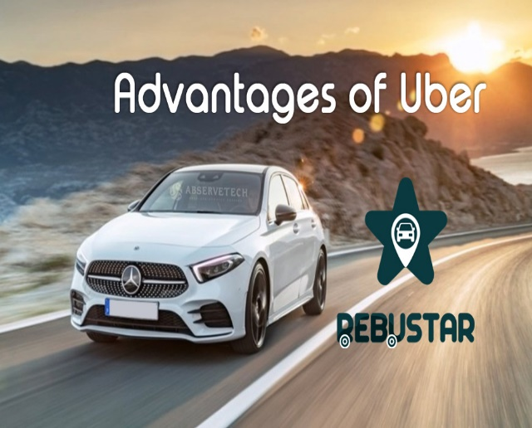

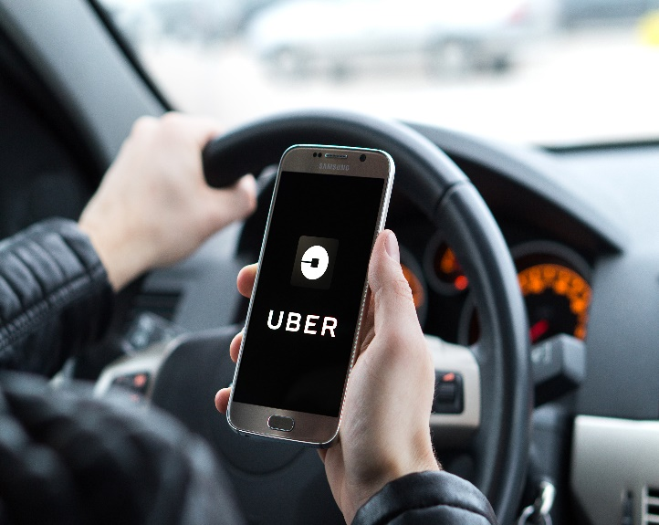

**DISVADVANTAGES**

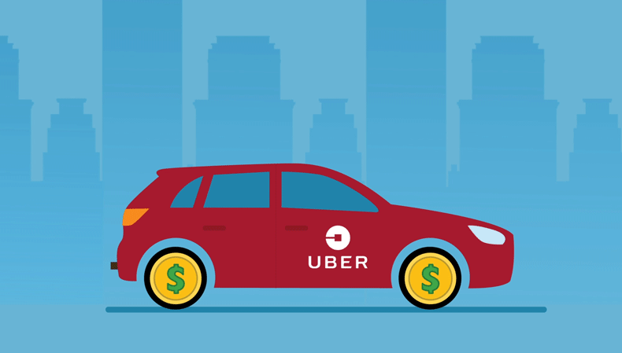

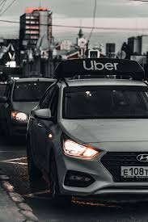

**5. APPLICATIONS**

**Uber process is simple but there is a lot going on behind the scenes. The secret key driving growth of the $51 billion start-up, is the big data it collects and leverages for insightful and intelligent decision making. While Uber moves people around the world without owning any cars, data moves Uber. With the foundation to build the most intelligent company on the planet by completely solving problems for riders –Big Data and Data Science are at the heart of everything Uber does - surge pricing, better cars, detecting fake rides, fake cards, fake ratings, estimating fares and driver ratings. Read on to understand how Uber makes clever use of big data and data science to reinvent transportation and logistics globally.**

**6. CONCLUSIONS**

**Uber is the company with a complicated history. Still, its founders had made something that was impossible: they survived sabotages, strikes, and discontents of the governments of different countries around the whole world. The necessity to provide people with good services at affordable prices is urgent nowadays. Not all people are able to use the quality they want. Uber opens new perspectives and possibilities.**

**However, its attempts to cooperate with big cities only are not enough to become one of the best. It is necessary to make more improvements and encourage changes. Drivers are eager to work at different places. Uber can provide drivers with jobs and citizens with transportation services.**

**7. FUTURE SCOPE**

**“Uber have been a net beneficiary of inflation,” said Zino, who said relatively flat expenses, especially for research and development, has made revenue gains like the second quarter’s 40% jump in revenue from its ride-hailing division drop to the bottom line. “They’re generating significant cash flow and will expand that. It’s a business that is all about scale.”**

**All of that is background for the push into an all-electric fleet.**

**The striking thing about Uber’s plan is how capital light it is, Devitt said – enough that Uber should be able to juggle it with rising stock repurchases. Hertz’s partnership with Uber lets drivers rent EVs for as little as $273 a week for a Chevy Bolt or Hyundai Kona and $299 for a Tesla Model 3, with up to 45% off public charging.**

**8.PERFORMANCE TESTING**

